** San Francisco Bay University**

**EE461L - Verilog HDL Lab**

**Week#1 Introduction to Verilog and**

**Combinational & Sequential Logic Design**

1. **Lab Outlines:**
2. Example “Hello World” & Simulation
3. Sequential Logic in RTL
4. Combinational Logic in RTL
5. **Lab Procedures:**

1. **Example “Hello World” & Simulation**

//-----------------------------------------------------

// This is my first Verilog Program

// Design Name : hello_world

// File Name : hello_world.v

// Function : This program will print 'hello world'

//-----------------------------------------------------

module helloWorld;

initial begin

$display ("Hello World!!!");

#10 $finish;

end

endmodule // End of Module helloWorld

-Run this program by the online compiler

You will see “Hello World!!!” on the monitor

-Why does hardware design need Verilog?

Traditional design: pen & paper

example: 1-bit full adder design

Step 1: Truth table buildup

Step 2: Get logic function & simplify it by K-map or other methods.

Step 3: Create gate logic schematic.

Verilog code:

{co, sum} = a + b + cin;

Logic Synthesiser(software)

Verilog code ==== > gate logic schematic

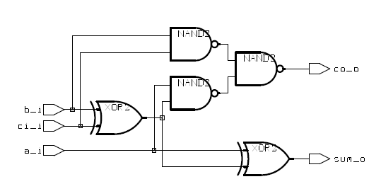

1. **HDL Level and examples:**

* **Behavior:** describe function only. We can't create logic schematic by synthesizer through it. Pure software likes high level computer language. Usually, it is used for design idea verification.

begin: count1s

reg [7:0] tempreg;

count = 0;

tempreg = rega;

while (tempreg)begin

if (tempreg[0]) count = count + 1;

tempreg = tempreg >> 1;

end

end

* **RTL (low level):** logic schematic can be created by synthesizer.
* **Gate level:** Final product of verilog design. It is equivalent to logic schematic.

module gates();

wire out0;

wire out1;

wire out2;

reg in1,in2,in3,in4;

not U1(out0,in1);

and U2(out1,in1,in2,in3,in4);

xor U3(out2,in1,in2,in3);

endmodule

1. **Combinational Logic & Synthesis in RTL**

* Design Example: 1-bit full adder

1. “continuous assignment” in oneBitFA1.v

module oneBitFA1(

input wire a_i,

input wire b_i,

input wire ci_i,

output wire sum_o,

output wire co_o

);

assign {co_o,sum_o} = a_i + b_i + ci_i;

endmodule

“always block” in oneBitFA2.v

module oneBitFA2(

input wire a_i,

input wire b_i,

input wire ci_i,

output reg sum_o,

output reg co_o

);

always @(a_i, b_i, ci_i)begin  
 {co_o, sum_o} = a_i + b_i + ci_i;

end

endmodule

1. **Sequential Logic in RTL**

Synchronous DFF:

> vi DFFSynch .v

module DFFSynch(

d_i,

rst_i,

clk_i,

q_o

);

input d_i,rst_i,clk_i;

output q_o;

reg q_o;

always @(posedge clk_i)begin

if(rst_i) q_o <= 0;

else q_o <= d_i;

end

endmodule

Asynchronous DFF:

> vi DFFAsynch .v

module DFFAsynch(

d_i,

rst_i,

clk_i,

q_o

);

input d_i,rst_i,clk_i;

output q_o;

reg q_o;

always @(posedge clk_i or posedge rst_i)begin

if(rst_i) q_o <= 0;

else q_o <= d_i;

end

endmodule

1. **Exercise: Combinational logic design**
   * + - 1. Directly run the module *helloWorld* in the online compiler

Output:

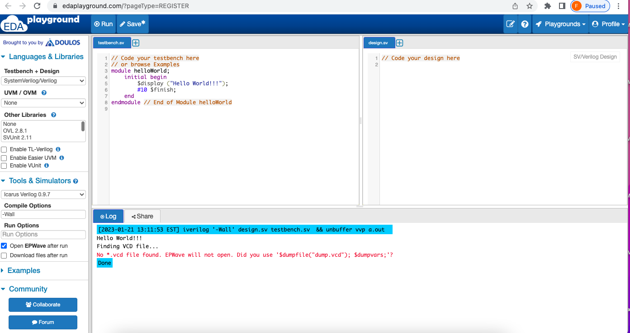

* + - * 1. Based the module *gates*, draw the digital circuit schematic.

Answer:

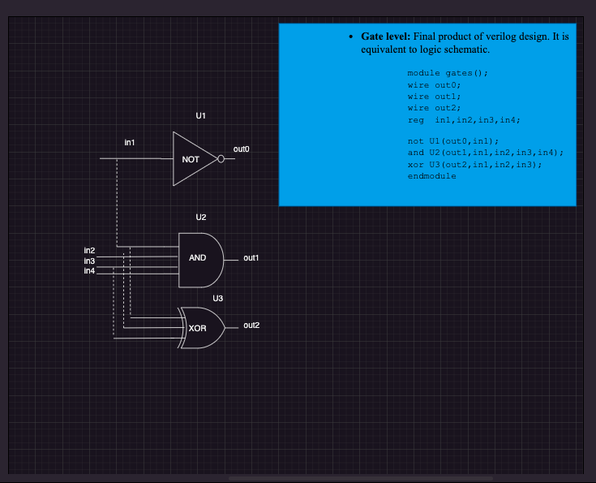

* + - * 1. Create the testbench first, and then simulate the design modules *oneBitFA1*, *oneBitFA2*, *DFFSynch*, and *DFFAsynch*.

**testbench for oneBitFA1**

module fullAdder_tb;

reg a_i, b_i, cin; // input variables are always assigned reg datatype

wire cout, sum;

oneBitFA1 U1(

.a_i(a_i),

.b_i(b_i),

.ci_i(cin),

.cout(cout),

.sum_o(sum)

);

initial begin

$dumpfile("waveform.vcd"); // fuile for dumping the variables

$dumpvars(2, fullAdder_tb)

a_i = 1'b0; // initialize Inputs

b_i = 1'b0;

cin = 1'b0;

#10 a_i = 1'b0;

#10 b_i = 1'b0;

#10 cin = 1'b1;

#10 a_i = 1'b0;

#10 b_i = 1'b1;

#10 cin = 1'b0;

#10 a_i = 1'b0;

#10 b_i = 1'b1;

#10 cin = 1'b1;

#10 a_i = 1'b1;

#10 b_i = 1'b0;

#10 cin = 1'b1;

end

endmodule

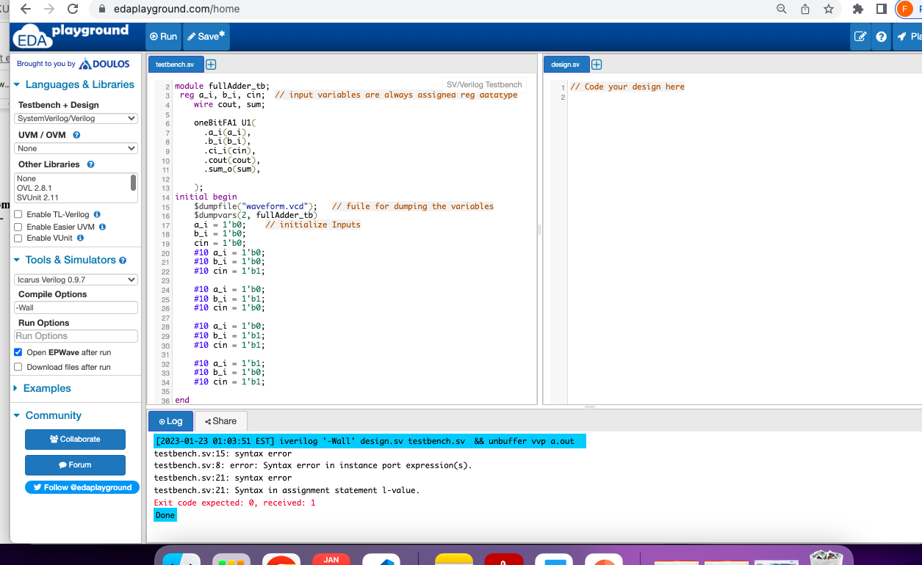

**testbench for oneBitFA2**

/timescale directive

`timescale 1ns / 1ps

module oneBitFA2;

//declare testbench variables

reg a_input,

reg b_input,

reg c_input;

wire sum,

wire c_output;

//instantiate the design module and connect to the testbench variables

full_adder instantiation

(

.a_i(a_input),

.b_i(b_input),

.ci_i(c_input),

.sum_o(sum),

.co_o(c_output));

initial

begin

$dumpfile("xyz.vcd");

$dumpvars;

//set stimulus to test the code

a_input=0;

b_input=0;

c_input=0;

#100 $finish;

end

//provide the toggling input (just like truth table input)

//this acts as the clock input

always #40 a_input=~a_input;

always #20 b_input=~b_input;

always #10 c_input=~c_input;

//display output if there’s a change in the input event

always @(a_input or b_input or c_input)

$monitor("At TIME(in ns)=%t, a=%d b=%d c=%d sum = %d Carry = %d", $time, a_input, b_input, c_input, sum, c_output);

endmodule

